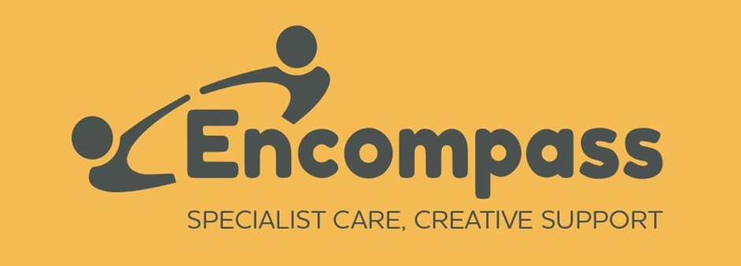  Registered Company No: 2526640  Registered Charity No: 1003779 | Registered Office:  Grove House  Millers Close  DORCHESTER  Dorset DT1 1SS  info@encompassdorset.co.uk  Tel & Fax: 01305 267483  www.encompassdorset.co.uk

Confidentiality Agreement

Whilst working for Encompass, we would like to draw your attention to our data protection and confidentiality policies and your responsibilities in maintaining the required duty of care to staff, service users and the company.
Confidential Information – What is it?
During the course of your employment with Encompass you may come into contact with or be required to process sensitive personal and financial information relating to staff, service users and the company.
Confidential information may be found in a variety of formats including paper, computerized (including portable devices such as laptops, Nourish handsets and memory sticks), visual and other versions of information storage media such as digital images and photographs. In addition, it covers oral communications, including the use of the telephone (including mobiles) and general conversation.
Encompass has a legal duty of care to its service users and staff and seeks to protect the confidentiality of staff and service users at all times by strict adherence to our policies on data protection and confidentiality. These can be viewed in full on the Encompass Info drive or by reference to your manager.
Your Responsibilities
You must at all times be aware of the importance of maintaining confidentiality of information gained during the course of your employment with Encompass and comply with Encompass policies relating Confidentiality and Data Protection and treat all information in a discreet and confidential manner. Particular attention is drawn to the following:

- Confidential information regarding service users must not be disclosed either verbally or in writing to any unauthorised persons. It is particularly important that you ensure the authenticity of any telephone enquiries received.

- Written records, computer records and correspondence pertaining to any aspect of the organisation’s activities must be kept securely at all times.

- If it is necessary to share confidential, personal or sensitive information in order to effectively carry out your work, you must make sure that as far as is reasonable this information will be exchanged on a strictly “need to know‟ basis and is used only for the purpose for which the information was given. This also applies in relation to disclosure of information to any relatives or family members who are also working at Encompass irrespective of their role or location. You must not discuss or disclose any confidential or sensitive information with family and relatives which could potentially undermine or create a conflict of interest within the company. If unsure, you must seek advice from your Manager.
- Conversations relating to confidential matters affecting service users should not take place in situations where they may be overheard by passers-by both inside and outside work, e.g. in corridors, reception areas, lifts, cloak rooms and car parks or other public areas.

- You must not discuss issues relating to Encompass, its staff or service users with any media representative without the express permission of the Chief Executive. If you have a genuine and reasonable concern about practices or unlawful acts at work and wish to report this to the appropriate authority, you must do so by using the Encompass Whistleblowing Policy and Procedure.

- The same confidentiality protocols should also be observed in relation to matters at work pertaining to work colleagues.

- All notes, memoranda, records and other documents relating to Encompass and in your possession are to be regarded as confidential and shall remain the property of Encompass and must be handed over by you to Encompass on demand and in any event upon termination of your employment.

- Any breach of this agreement may be regarded as serious misconduct and may be subject to disciplinary action, including termination of your employment where appropriate. Should you breach this Agreement after your employment has ended, the organisation may also conider legal action against you in recovery of any losses suffered by Encompass.

Signed ……………………………………………………………Date ………………………………….

NAME…………………………………………………………………………………………………………..

